PAST SIMPLE- IRREGULAR VERBS
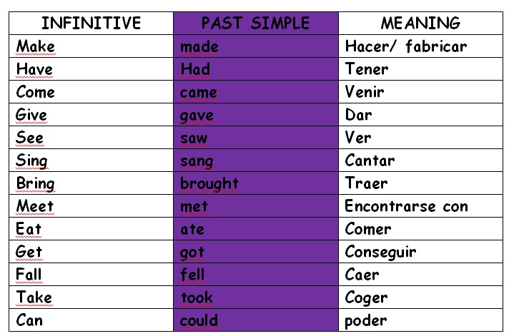
- Make these sentences negative (recuerda mirar la tabla de los verbos irregulares que copiamos en nuestros cuadernos la semana pasada)

- I made a carrot cake last week- I didn’t make a carrot cake last week.
- They had a fantastic birthday party - _______________
______________________________
- Rihanna sang “Umbrella”, her most famous song - _______
______________________________
- She saw the movie at the cinema - __________________
______________________________
- Sarah gave him a very expensive present - ____________
______________________________

